**Learn it on  http://sqlbolt.com/**

**SQL BASIC INTRODUCTION TASK COMPLETED**



[**SQL Lesson 1: SELECT queries 101**](https://gist.github.com/antoshkoo/a415100a8c26db2bf4a81fe50d9f5282#sql-lesson-1-select-queries-101)

Link on this lesson: <https://sqlbolt.com/lesson/select_queries_introduction>

1. Find the title of each film

SELECT title FROM movies

1. Find the director of each film

SELECT director FROM movies

1. Find the title and director of each film

SELECT title, director FROM movies

1. Find the title and year of each film

SELECT title, year FROM movies

1. Find all the information about each film

SELECT * FROM movies

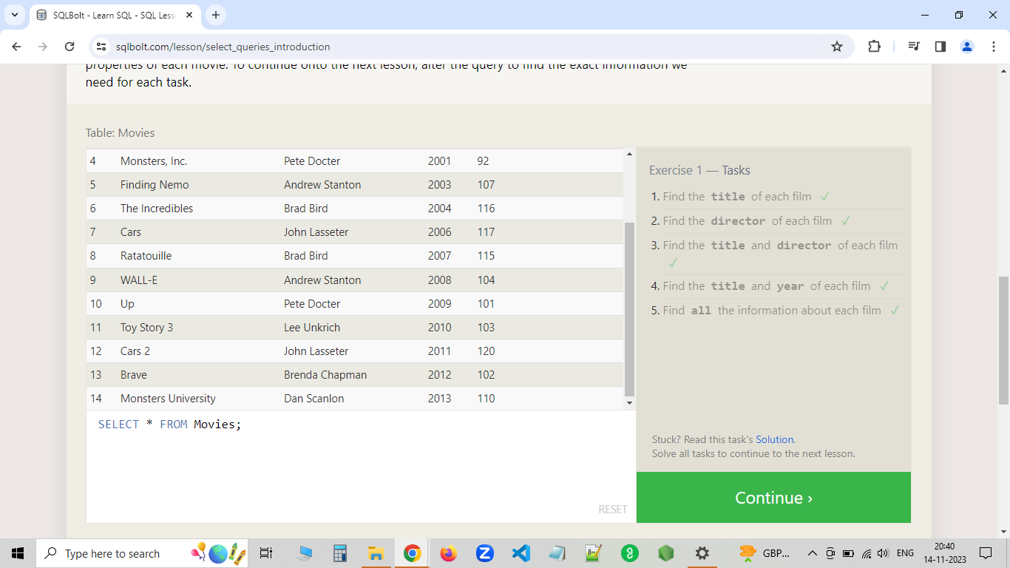

[**SQL Lesson 2: Queries with constraints #1**](https://gist.github.com/antoshkoo/a415100a8c26db2bf4a81fe50d9f5282#sql-lesson-2-queries-with-constraints-1)

Link on this lesson: <https://sqlbolt.com/lesson/select_queries_with_constraints>

1. Find the movie with a row id of 6

SELECT * FROM movies WHERE id = 6

1. Find the movies released in the years between 2000 and 2010

SELECT * FROM movies WHERE year BETWEEN 2000 AND 2010

1. Find the movies not released in the years between 2000 and 2010

SELECT * FROM movies WHERE year NOT BETWEEN 2000 AND 2010

1. Find the first 5 Pixar movies and their release year

SELECT * FROM movies WHERE id BETWEEN 1 AND 5

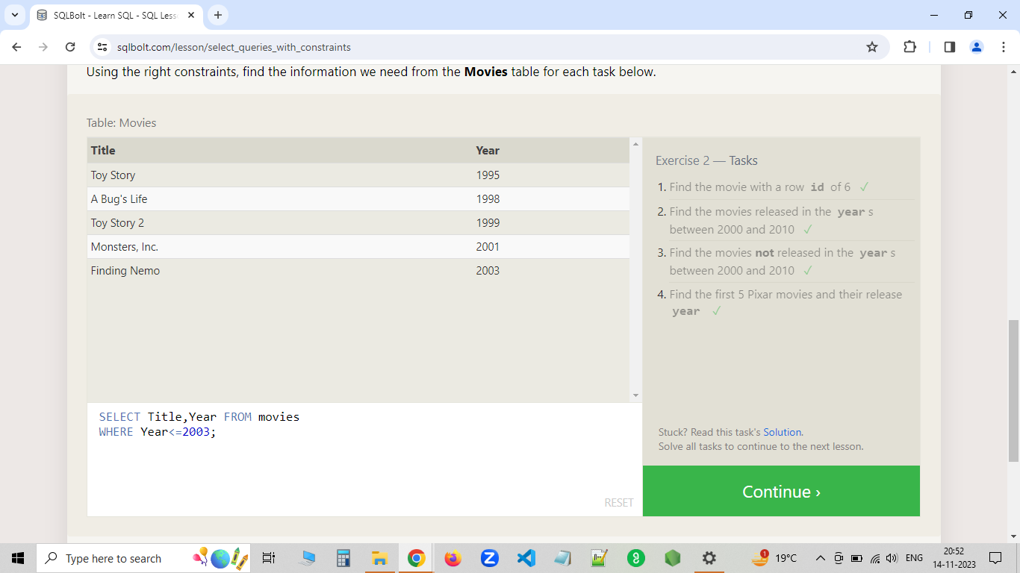

[**SQL Lesson 3: Queries with constraints #2**](https://gist.github.com/antoshkoo/a415100a8c26db2bf4a81fe50d9f5282#sql-lesson-3-queries-with-constraints-2)

Link on this lesson: <https://sqlbolt.com/lesson/select_queries_with_constraints_pt_2>

1. Find all the Toy Story movies

SELECT * FROM movies WHERE title LIKE 'Toy Story%'

1. Find all the movies directed by John Lasseter

SELECT * FROM movies WHERE director LIKE 'John Lasseter'

1. Find all the movies (and director) not directed by John Lasseter

SELECT * FROM movies WHERE director NOT LIKE 'John Lasseter'

1. Find all the WALL-* movies

SELECT * FROM movies WHERE title LIKE 'WALL-%'

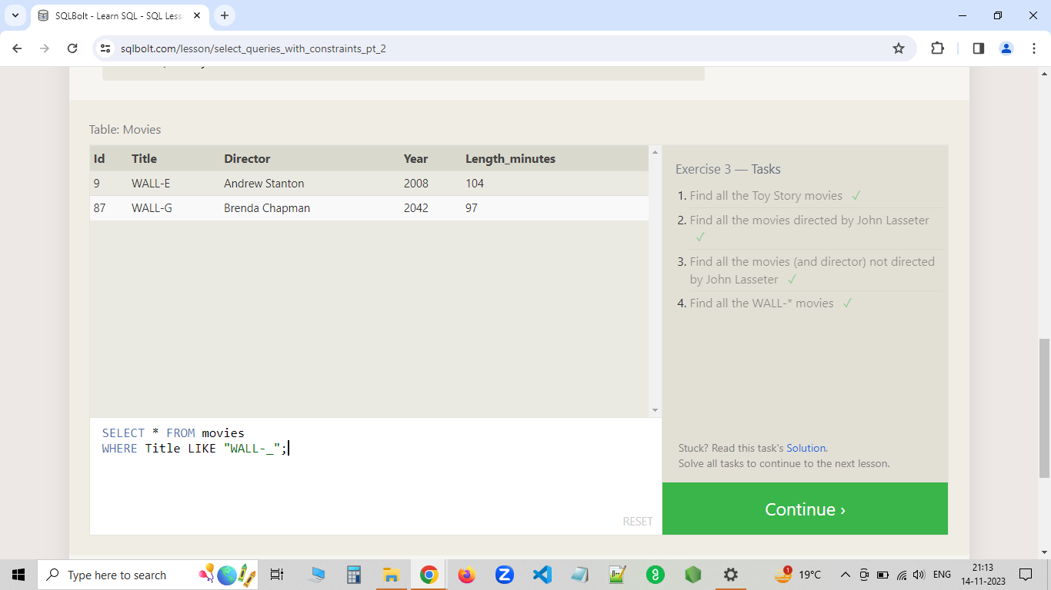

[**SQL Lesson 4: Filtering and sorting Query results**](https://gist.github.com/antoshkoo/a415100a8c26db2bf4a81fe50d9f5282#sql-lesson-4-filtering-and-sorting-query-results)

Link on this lesson: <https://sqlbolt.com/lesson/filtering_sorting_query_results>

1. List all directors of Pixar movies (alphabetically), without duplicates

SELECT DISTINCT director FROM movies ORDER BY director ASC

1. List the last four Pixar movies released (ordered from most recent to least)

SELECT * FROM movies ORDER BY year DESC LIMIT 4

1. List the first five Pixar movies sorted alphabetically

SELECT * FROM movies ORDER BY title ASC LIMIT 5

1. List the next five Pixar movies sorted alphabetically

SELECT * FROM movies ORDER BY title ASC LIMIT 5 OFFSET 5

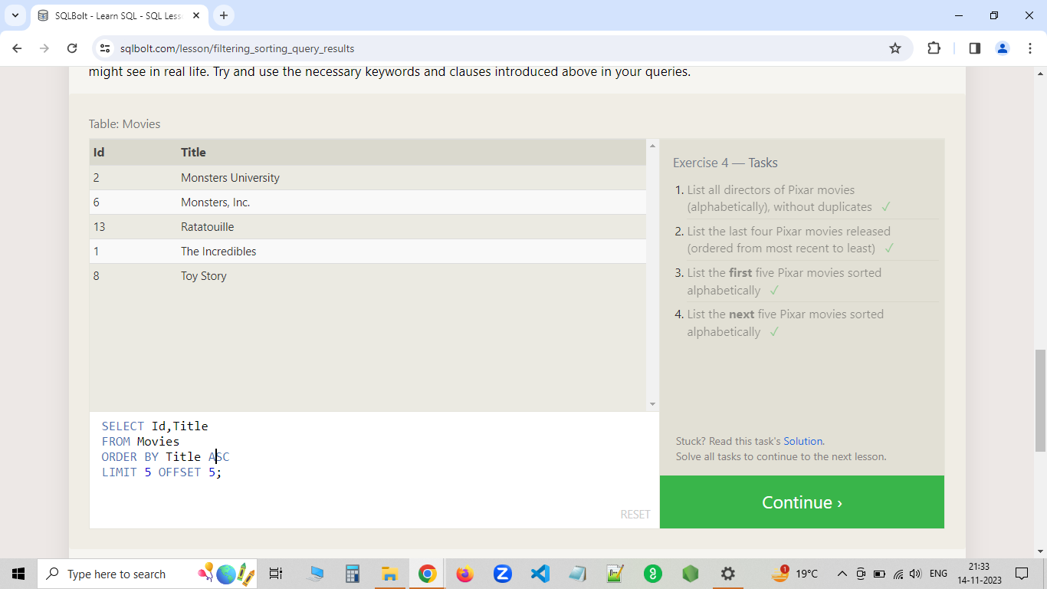

[**SQL Review: Simple SELECT Queries**](https://gist.github.com/antoshkoo/a415100a8c26db2bf4a81fe50d9f5282#sql-review-simple-select-queries)

Link on this lesson: <https://sqlbolt.com/lesson/select_queries_review>

1. List all the Canadian cities and their populations

SELECT city, population FROM north_american_cities

WHERE country LIKE 'Canada'

1. Order all the cities in the United States by their latitude from north to south

SELECT city FROM north_american_cities

WHERE country LIKE 'United States'

ORDER BY latitude DESC

1. List all the cities west of Chicago, ordered from west to east

SELECT city FROM north_american_cities

WHERE longitude < -87.629798

ORDER BY longitude ASC

1. List the two largest cities in Mexico (by population)

SELECT city FROM north_american_cities

WHERE country LIKE 'Mexico'

ORDER BY Population DESC

LIMIT 2

1. List the third and fourth largest cities (by population) in the United States and their population

SELECT city, population FROM north_american_cities

WHERE country LIKE 'United States'

ORDER BY Population DESC

LIMIT 2 OFFSET 2

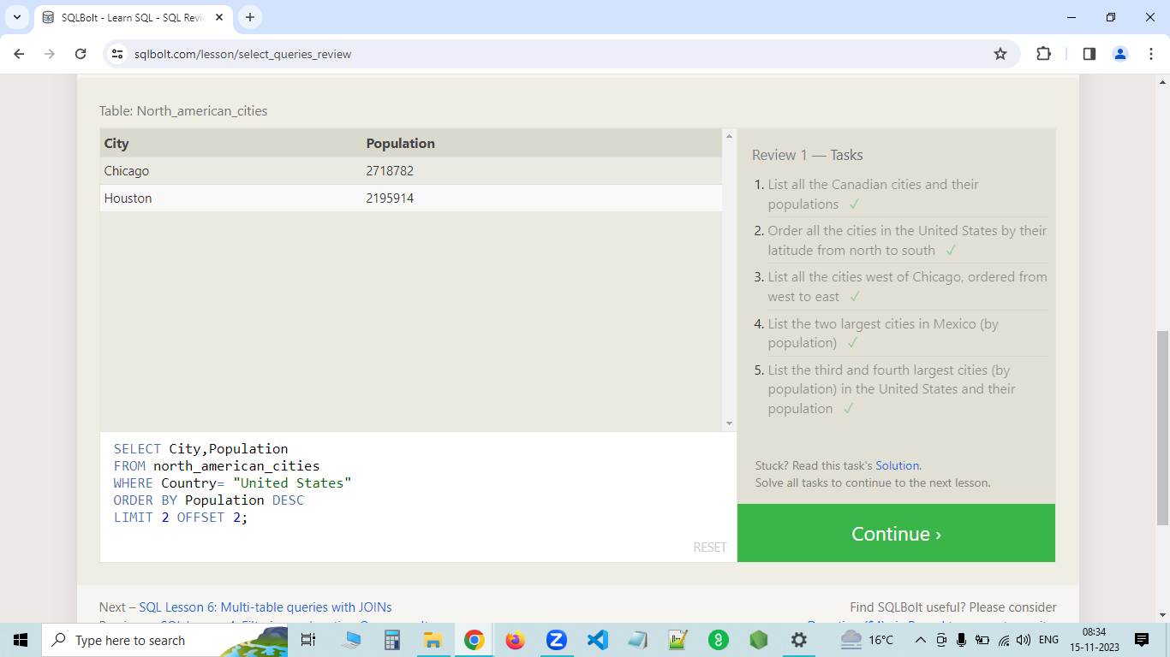

[**SQL Lesson 6: Multi-table queries with JOINs**](https://gist.github.com/antoshkoo/a415100a8c26db2bf4a81fe50d9f5282#sql-lesson-6-multi-table-queries-with-joins)

Link on this lesson: <https://sqlbolt.com/lesson/select_queries_with_joins>

1. Find the domestic and international sales for each movie

SELECT title, domestic_sales, international_sales FROM movies

INNER JOIN boxoffice

ON id = boxoffice.movie_id

1. Show the sales numbers for each movie that did better internationally rather than domestically

SELECT title, domestic_sales, international_sales FROM movies

INNER JOIN boxoffice

ON id = boxoffice.movie_id

WHERE international_sales > domestic_sales

1. List all the movies by their ratings in descending order

SELECT title, rating FROM movies

INNER JOIN boxoffice

ON id = boxoffice.movie_id

ORDER BY rating DESC

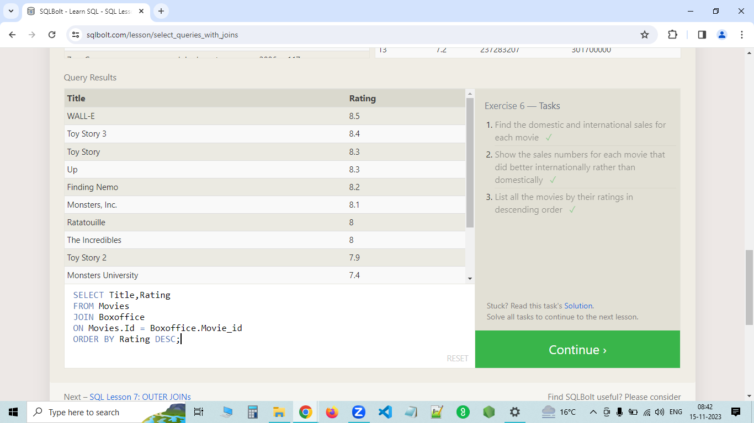

[**SQL Lesson 7: OUTER JOINs**](https://gist.github.com/antoshkoo/a415100a8c26db2bf4a81fe50d9f5282#sql-lesson-7-outer-joins)

Link on this lesson: <https://sqlbolt.com/lesson/select_queries_with_outer_joins>

1. Find the list of all buildings that have employees

SELECT DISTINCT building FROM employees

LEFT JOIN buildings

1. Find the list of all buildings and their capacity

SELECT * FROM buildings

1. List all buildings and the distinct employee roles in each building (including empty buildings)

SELECT DISTINCT building_name, role FROM buildings

LEFT JOIN employees

ON building_name = building

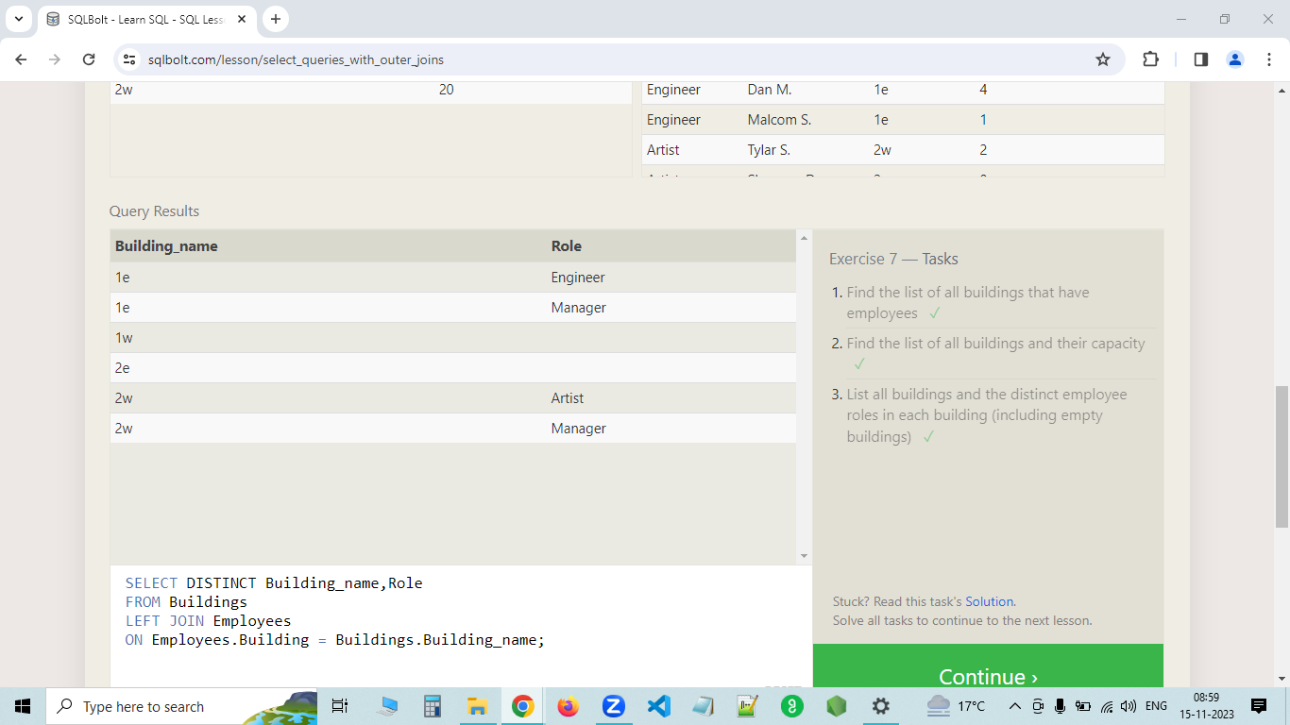

[**SQL Lesson 8: A short note on NULLs**](https://gist.github.com/antoshkoo/a415100a8c26db2bf4a81fe50d9f5282#sql-lesson-8-a-short-note-on-nulls)

Link on this lesson: <https://sqlbolt.com/lesson/select_queries_with_nulls>

1. Find the name and role of all employees who have not been assigned to a building

SELECT name, role FROM employees WHERE building IS NULL

1. Find the names of the buildings that hold no employees

SELECT building_name FROM buildings

LEFT JOIN employees

ON building = building_name

WHERE building IS NULL

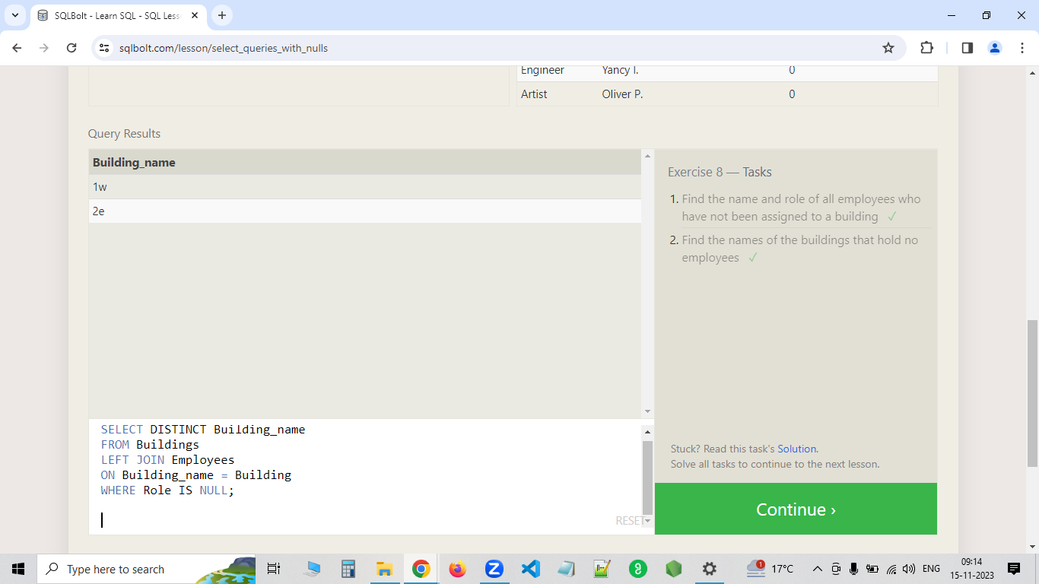

[**SQL Lesson 9: Queries with expressions**](https://gist.github.com/antoshkoo/a415100a8c26db2bf4a81fe50d9f5282#sql-lesson-9-queries-with-expressions)

Link on this lesson: <https://sqlbolt.com/lesson/select_queries_with_expressions>

1. List all movies and their combined sales in millions of dollars

SELECT title, (domestic_sales + international_sales) / 1000000 AS sales FROM movies

LEFT JOIN boxoffice

ON id = boxoffice.movie_id

1. List all movies and their ratings in percent

SELECT title, rating * 10 AS rating FROM movies

LEFT JOIN boxoffice

ON id = boxoffice.movie_id

1. List all movies that were released on even number years

SELECT title, year FROM movies WHERE year % 2 = 0

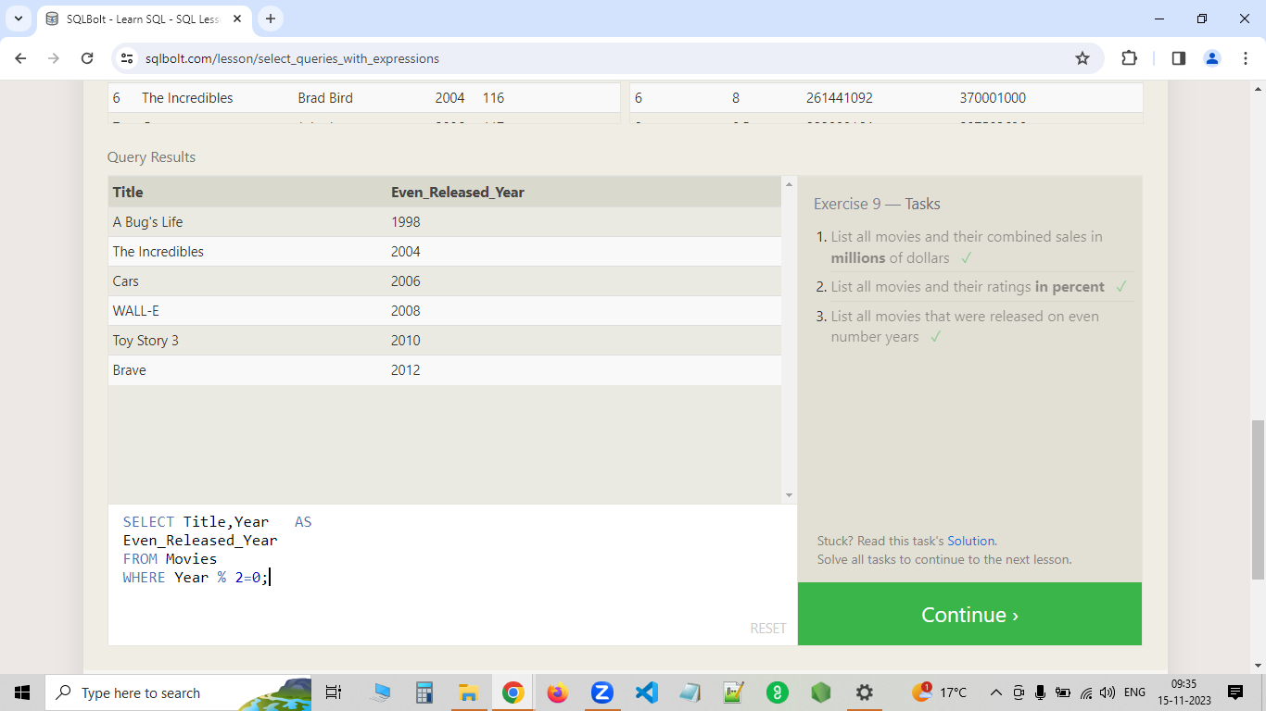

[**SQL Lesson 10: Queries with aggregates (Pt. 1)**](https://gist.github.com/antoshkoo/a415100a8c26db2bf4a81fe50d9f5282#sql-lesson-10-queries-with-aggregates-pt-1)

Link on this lesson: <https://sqlbolt.com/lesson/select_queries_with_aggregates>

1. Find the longest time that an employee has been at the studio

SELECT MAX(years_employed) AS max_employed FROM employees

1. For each role, find the average number of years employed by employees in that role

SELECT role, AVG(years_employed) AS avg_years FROM employees GROUP BY role

1. Find the total number of employee years worked in each building

SELECT building, SUM(years_employed) AS total_years FROM employees GROUP BY building

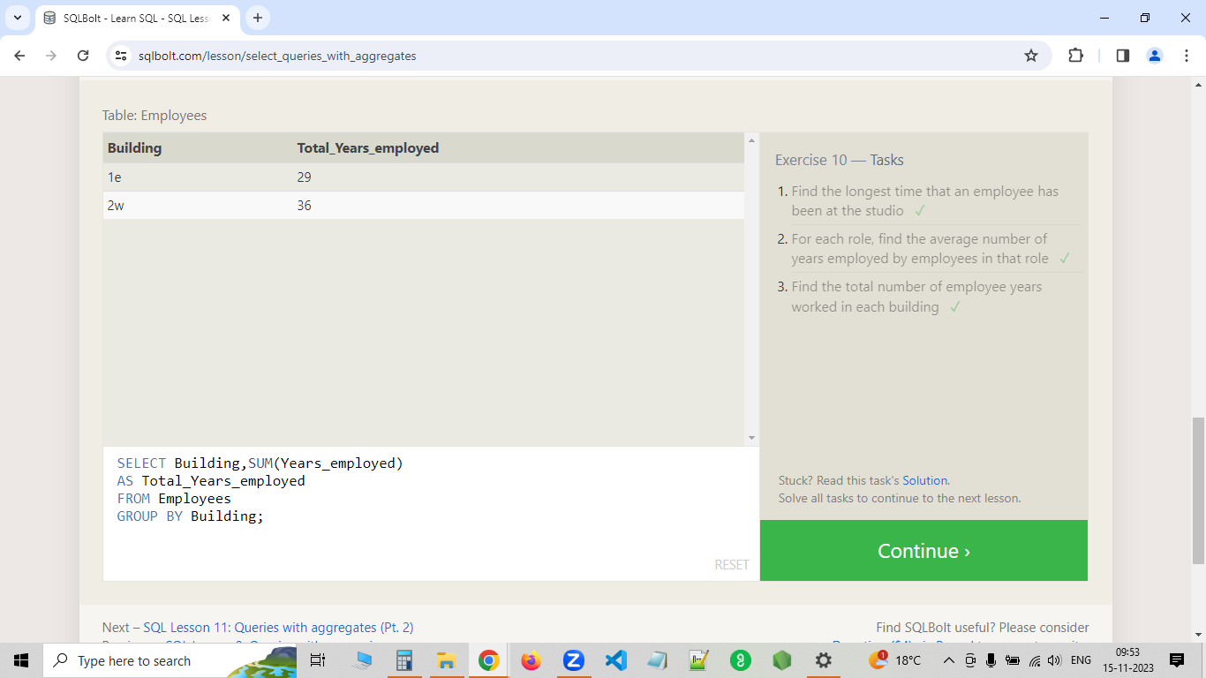

[**SQL Lesson 11: Queries with aggregates (Pt. 2)**](https://gist.github.com/antoshkoo/a415100a8c26db2bf4a81fe50d9f5282#sql-lesson-11-queries-with-aggregates-pt-2)

Link on this lesson: <https://sqlbolt.com/lesson/select_queries_with_aggregates_pt_2>

1. Find the number of Artists in the studio (without a HAVING clause)

SELECT COUNT() AS artists FROM employees WHERE role LIKE 'Artist'

1. Find the number of Employees of each role in the studio

SELECT role, COUNT() AS people_in_roles FROM employees GROUP BY role

1. Find the total number of years employed by all Engineers

SELECT SUM(years_employed) AS engineers_years FROM employees GROUP BY role HAVING role LIKE 'Engineer'

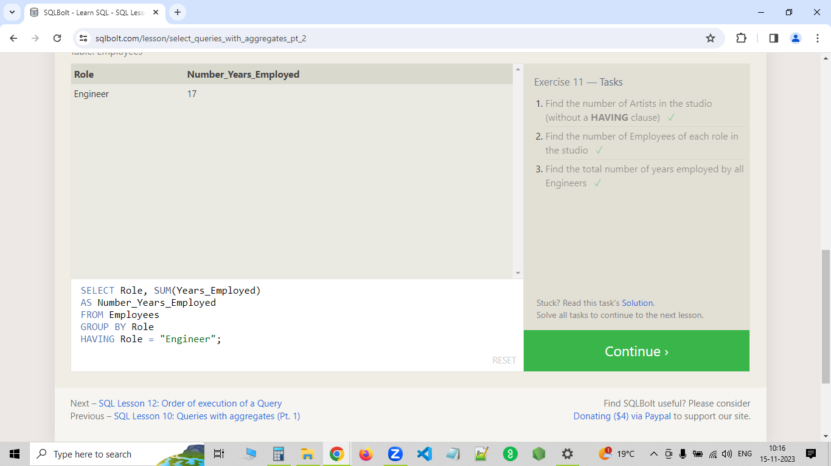

[**SQL Lesson 12: Order of execution of a Query**](https://gist.github.com/antoshkoo/a415100a8c26db2bf4a81fe50d9f5282#sql-lesson-12-order-of-execution-of-a-query)

Link on this lesson: <https://sqlbolt.com/lesson/select_queries_order_of_execution>

1. Find the number of movies each director has directed

SELECT director, COUNT() AS movies FROM movies GROUP BY director

1. Find the total domestic and international sales that can be attributed to each director

SELECT director, SUM(domestic_sales + international_sales) AS sales FROM movies

LEFT JOIN boxoffice

ON id = boxoffice.movie_id

GROUP BY director

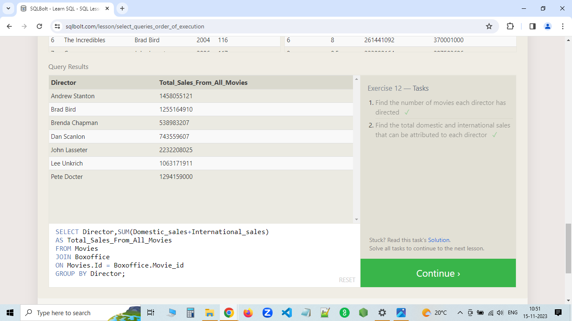

[**SQL Lesson 13: Inserting rows**](https://gist.github.com/antoshkoo/a415100a8c26db2bf4a81fe50d9f5282#sql-lesson-13-inserting-rows)

Link on this lesson: <https://sqlbolt.com/lesson/inserting_rows>

1. Add the studio's new production, Toy Story 4 to the list of movies (you can use any director)

INSERT INTO movies

(title, director)

VALUES

('Toy Story 4', 'Antoshkoo')

1. Toy Story 4 has been released to critical acclaim! It had a rating of 8.7, and made 340 million domestically and 270 million internationally. Add the record to the BoxOffice table.

INSERT INTO boxoffice

VALUES

(15, 8.7, 340000000, 270000000)

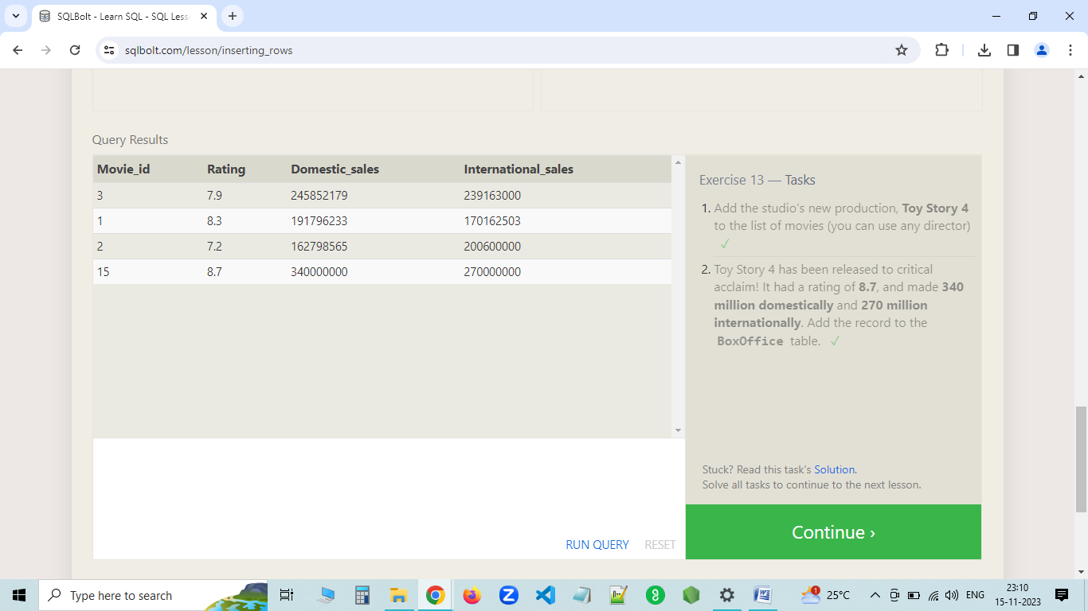

[**SQL Lesson 14: Updating rows**](https://gist.github.com/antoshkoo/a415100a8c26db2bf4a81fe50d9f5282#sql-lesson-14-updating-rows)

Link on this lesson: <https://sqlbolt.com/lesson/updating_rows>

1. The director for A Bug's Life is incorrect, it was actually directed by John Lasseter

UPDATE movies

SET director = "John Lasseter"

WHERE title = "Bug's Life"

1. The year that Toy Story 2 was released is incorrect, it was actually released in 1999

UPDATE movies

SET year = 1999

WHERE title = 'Toy Story 2'

1. Both the title and director for Toy Story 8 is incorrect! The title should be "Toy Story 3" and it was directed by Lee Unkrich

UPDATE movies

SET title = 'Toy Story 3',

director = 'Lee Unkrich'

WHERE title = 'Toy Story 8'

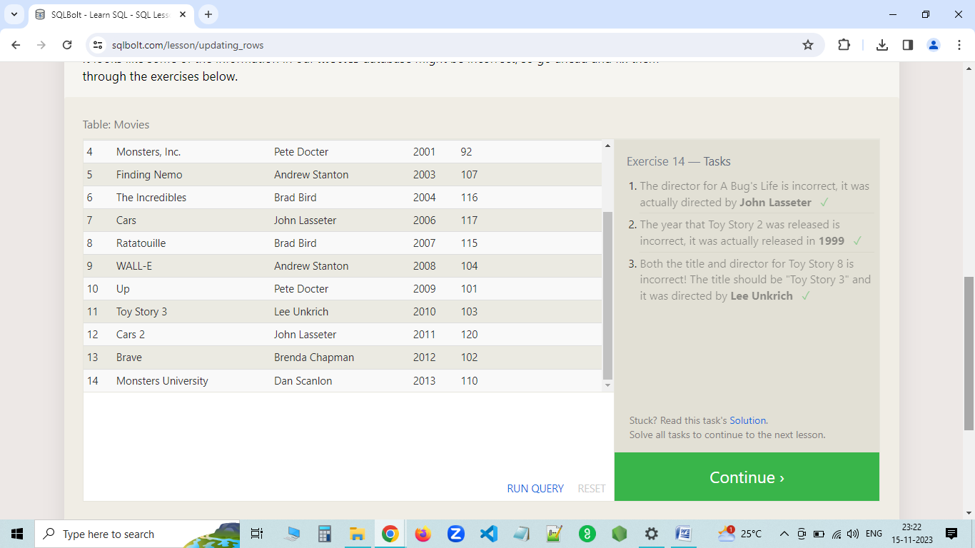

[**SQL Lesson 15: Deleting rows**](https://gist.github.com/antoshkoo/a415100a8c26db2bf4a81fe50d9f5282#sql-lesson-15-deleting-rows)

Link on this lesson: <https://sqlbolt.com/lesson/deleting_rows>

1. This database is getting too big, lets remove all movies that were released before 2005.

DELETE FROM movies WHERE year < 2005

1. Andrew Stanton has also left the studio, so please remove all movies directed by him.

DELETE FROM movies WHERE director = 'Andrew Stanton'

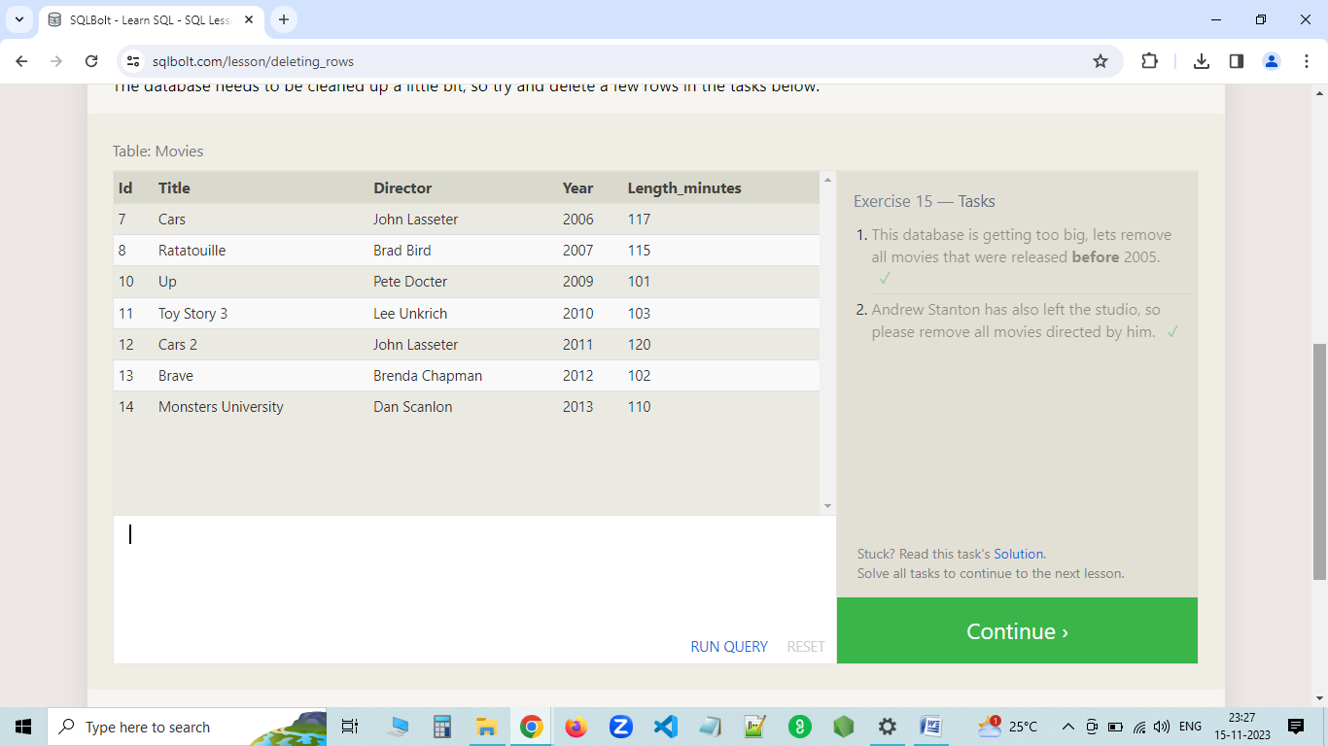

[**SQL Lesson 16: Creating tables**](https://gist.github.com/antoshkoo/a415100a8c26db2bf4a81fe50d9f5282#sql-lesson-15-deleting-rows-1)

Link on this lesson: <https://sqlbolt.com/lesson/creating_tables>

1. Create a new table named Database with the following columns:
   * Name A string (text) describing the name of the database
   * Version A number (floating point) of the latest version of this database
   * Download_count An integer count of the number of times this database was downloaded This table has no constraints.

CREATE TABLE database (

name TEXT,

version INTEGER,

download_count INTEGER

)

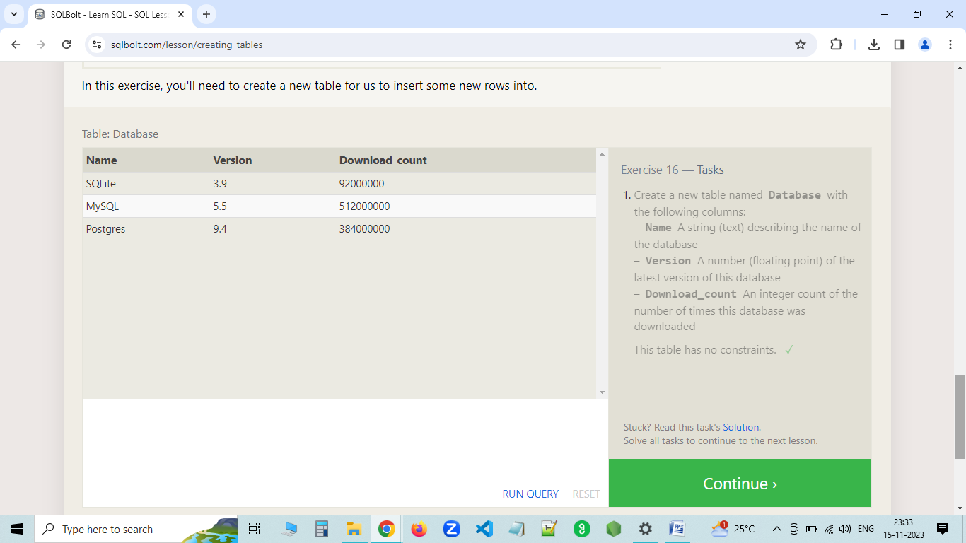

[**SQL Lesson 17: Altering tables**](https://gist.github.com/antoshkoo/a415100a8c26db2bf4a81fe50d9f5282#sql-lesson-17-altering-tables)

Link on this lesson: # <https://sqlbolt.com/lesson/altering_tables>

1. Add a column named Aspect_ratio with a FLOAT data type to store the aspect-ratio each movie was released in.

ALTER TABLE movies ADD aspect_ratio FLOAT

1. Add another column named Language with a TEXT data type to store the language that the movie was released in. Ensure that the default for this language is English.

ALTER TABLE movies ADD language TEXT DEFAULT 'English'

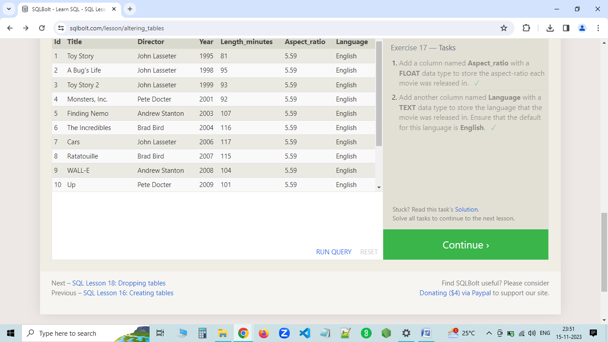

[**SQL Lesson 18: Dropping tables**](https://gist.github.com/antoshkoo/a415100a8c26db2bf4a81fe50d9f5282#sql-lesson-18-dropping-tables)

Link on this lesson: # <https://sqlbolt.com/lesson/dropping_tables>

1. We've sadly reached the end of our lessons, lets clean up by removing the Movies table

DROP TABLE movies

1. And drop the BoxOffice table as well

DROP TABLE boxoffice

[**SQL Lesson 18: Dropping tables**](https://gist.github.com/antoshkoo/a415100a8c26db2bf4a81fe50d9f5282#sql-lesson-18-dropping-tables)

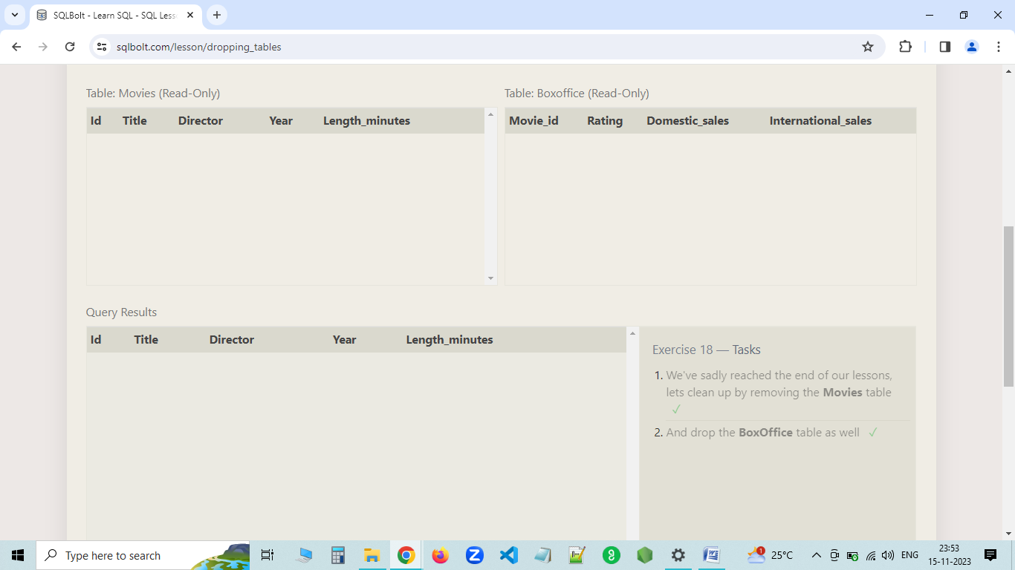

**SQL BASIC INTRODUCTION TASK COMPLETED**



**THANKYOU**